[Editable section]
Your clinic’s details
[phone]
[Editable section]
Your clinic logo

9009 3800

UR Label Medications

9815 2555

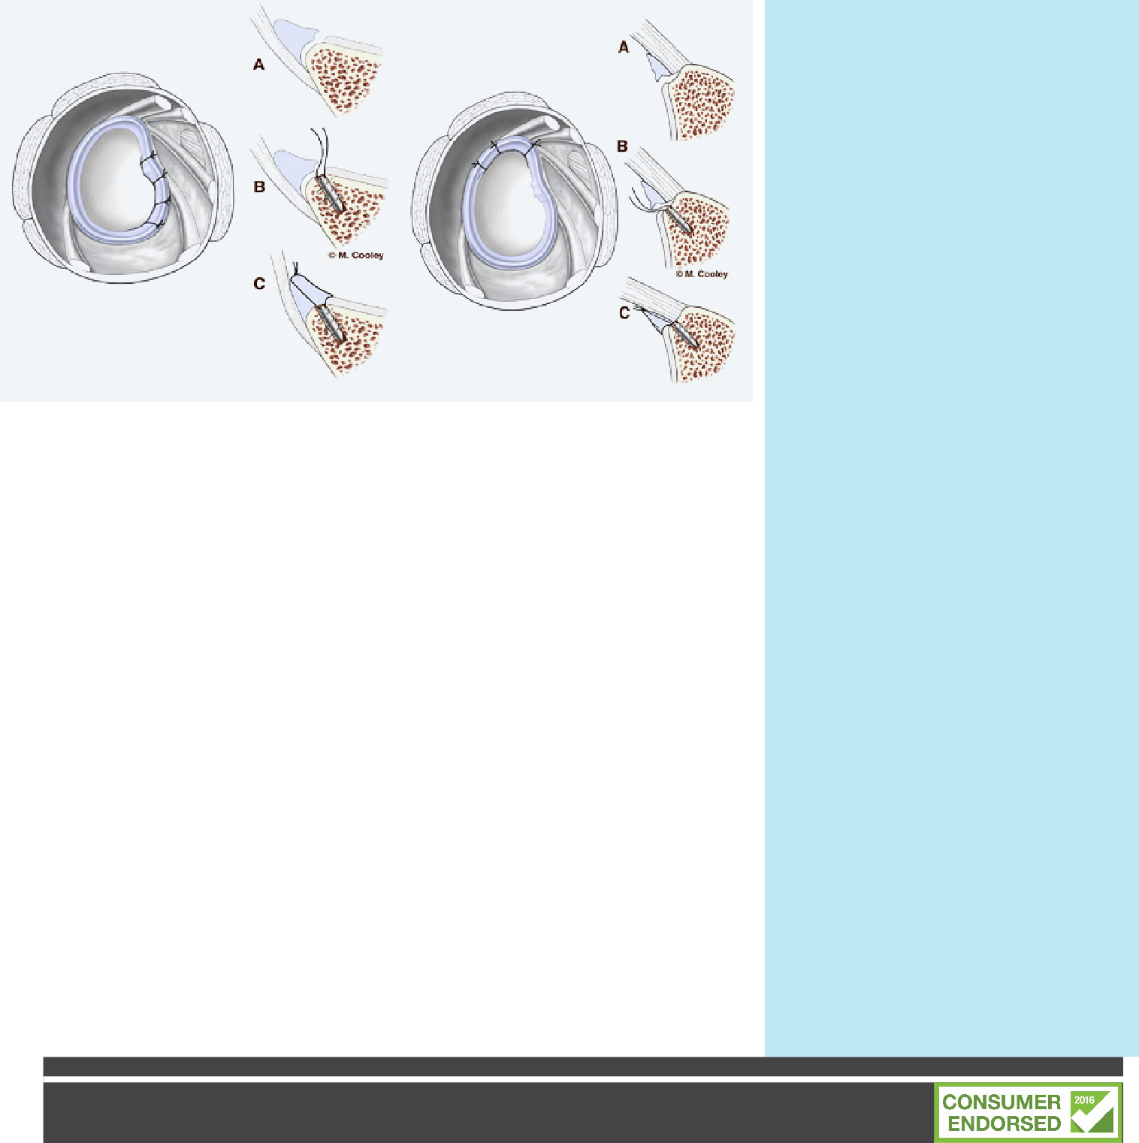

Shoulder Instability
Shoulder instability is a condition in which the shoulder joint (gleno-humeral joint) is too loose, leading to the arm slipping out of the shoulder socket (also known as shoulder dislocation).
Instability can occur naturally, or as a result of trauma to the shoulder. Damage can occur to a range of different tissues, some of which have a poor natural healing capacity. In the case of traumatic dislocation, cartilage and bone, along with the shoulder capsule and ligament tissue can be damaged.
Damaged tissues may fail to provide support to the shoulder and further dislocations may occur. This is especially so if the patient performs throwing activities or risks landing on an outstretched arm. Therefore reconstructive surgery is necessary. Reconstruction can take many forms depending upon the damage done. This can take the form of anchoring the torn labrum back in place, tightening the capsule or using bony blocks (Laterjet Reconstruction) to stabilise the shoulder.
SLAP Reconstruction
The term SLAP stands for Superior Labrum Anterior and Posterior. In a SLAP injury, the top (superior) part of the labrum is injured. This top area is also where the biceps tendon attaches to the labrum. A SLAP tear occurs both in front (anterior) and back (posterior) of this attachment point. The biceps tendon can be involved in the injury, as well.
There are several different types of SLAP tears. Your surgeon will determine how best to repair your SLAP injury once they see it fully during arthroscopic surgery. This may require simply removing the torn part of the labrum, or reattaching the torn part using stitches. Some SLAP injuries require cutting the biceps tendon attachment.
Your surgeon will decide the best repair option based upon the type of tear you have, as well as your age, activity level, and the presence of any other injuries seen during the surgery.

Dressings

The incisions are usually closed with small tapes and additional s t i t c h e s T h e w o u n d s a r e covered with a showerproof dressing.
Your Dressing Protocols for the next 2 weeks is -
Sling
You will have a sling following your surgery. You can come out of the sling for gentle exercising
and showering.

Review
You should have an appointment made 1-2 weeks following your surgery. Physiotherapy may start after this.

Driving

This will vary greatly depending upon your circumstances. Your surgeon will discuss with you time frames for driving.

Activities

Unless otherwise instructed you cannot take weight through your arm. You are not to move or hold the arm by itself. All movements must be passive and supported.

Getting dressed, thread your arm through your sleeve first and off last. Button up shirts or loose t shirts are best.
Time off work depends upon the type of procedure and the job that you do. Most patients return to sedentary work after a couple of weeks. Getting to and from work will be harder than you think and your shoulder will be easily irritated. Your Specialist and Physio will be able to guide you with this.

Sleeping

Comfortable sleeping positions can be difficult to find. Generally semi reclined positions work best. Use either lots of pillows or a recliner chair if you have one. So long as the arm is not under p r e s s u r e , w h a t e v e r i s comfortable is the right position.

Showering

You can shower after days. There is a shower proof dressing over your wound. To wash under your arm, lean forward and let the hand dangle, you can then use your other arm to access your armpit.

Medication

Yo u will be provided with medication upon your departure f rom hospital. Follow the instructions as described to you by your nurse. As a general rule, your medication requirements should continue to decrease over the early post-operative period.
Remember if you are using codeine based products that constipation can be an issue so keep up the water and a fibre b a s e d p r o d u c t s u c h a s Metamucil/ Coloxyl can be of assistance.

Physiotherapy

Y o u w i l l b e s e e n b y a physiotherapist whilst in hospital at the request of your surgeon (for uninsured patients there will be a small fee for this) to ensure your recovery is as quick as
possible. Exercises and advice will be given to help get you going and you will be shown how to use your sling. The most important thing in the first couple of weeks is to rest and ice your shoulder. This will give it the best opportunity to heal, and reduce the chance of complications. Rehabilitation commences at 1-2 weeks to m a i n t a i n y o u r a l l o w a b l e movement. You will require extensive therapy to get the most from your operation. You must not use heavy weights or resistance with your arm.Your Surgeon or Physiotherapist will be able to guide you on time frames regarding this.
Please call the Physiotherapist on 9815 2555 if you have any queries.

Complications

Shoulder Surgery is generally a v e r y s a f e p r o c e d u r e a n d complications are uncommon, however despite the highest s u r g i c a l s t a n d a r d s a n d precautions they can occur. Potential serious problems include infection and vein thrombosis (blood clots). An onset of fevers or sweats, or i n c r e a s i n g r e d n e s s a n d discharge from or around the wound can indicate that an infection is present. Please call if this occurs.

If you experience fevers, persistent swelling or bleeding or unusual pain in the arm or calf you should call the ward on 9009 3800 or contact your surgeon or attend to your GP or nearest hospital emergency department.

You may also experience numbness in the elbow or arm due to minor nerve damage which is normal with surgery. This can take months to resolve.

All information in this brochure is a guide and is the opinion of Glenferrie Private Hospital
Reviewed 1.9.19

