[Editable section]
Your clinic logo
[Editable section]
Your clinic’s details or detele
[phone]

9009 3800

UR Label Medications

9815 2555

Sub Acromial Decompression (SAD)
As we age, bone spurs (bone growth) can develop on a part of the shoulder blade called the acromion. This can then cause irritation to other tissues of the shoulder. One such tissue is called a bursa which is a small fluid filled sack (imagine a small water balloon). Repetitive irritation of the bursa can lead to a condition called bursitis (inflamed bursa). The inflamed bursa or the bone spur can further irritate tendons which pass through the area, leading to tendon swelling and ‘wear and tear’.
Your surgeon will look into the area called the subacromial space within your shoulder. This will be either directly through the arthroscope, or at pictures sent from the arthroscope to a monitor. They’ll insert specially designed surgical instruments through the small cuts and reshape this part of your shoulder blade. Your surgeon may also decide to repair any damaged tendons at the same time.
AC Joint Debridement

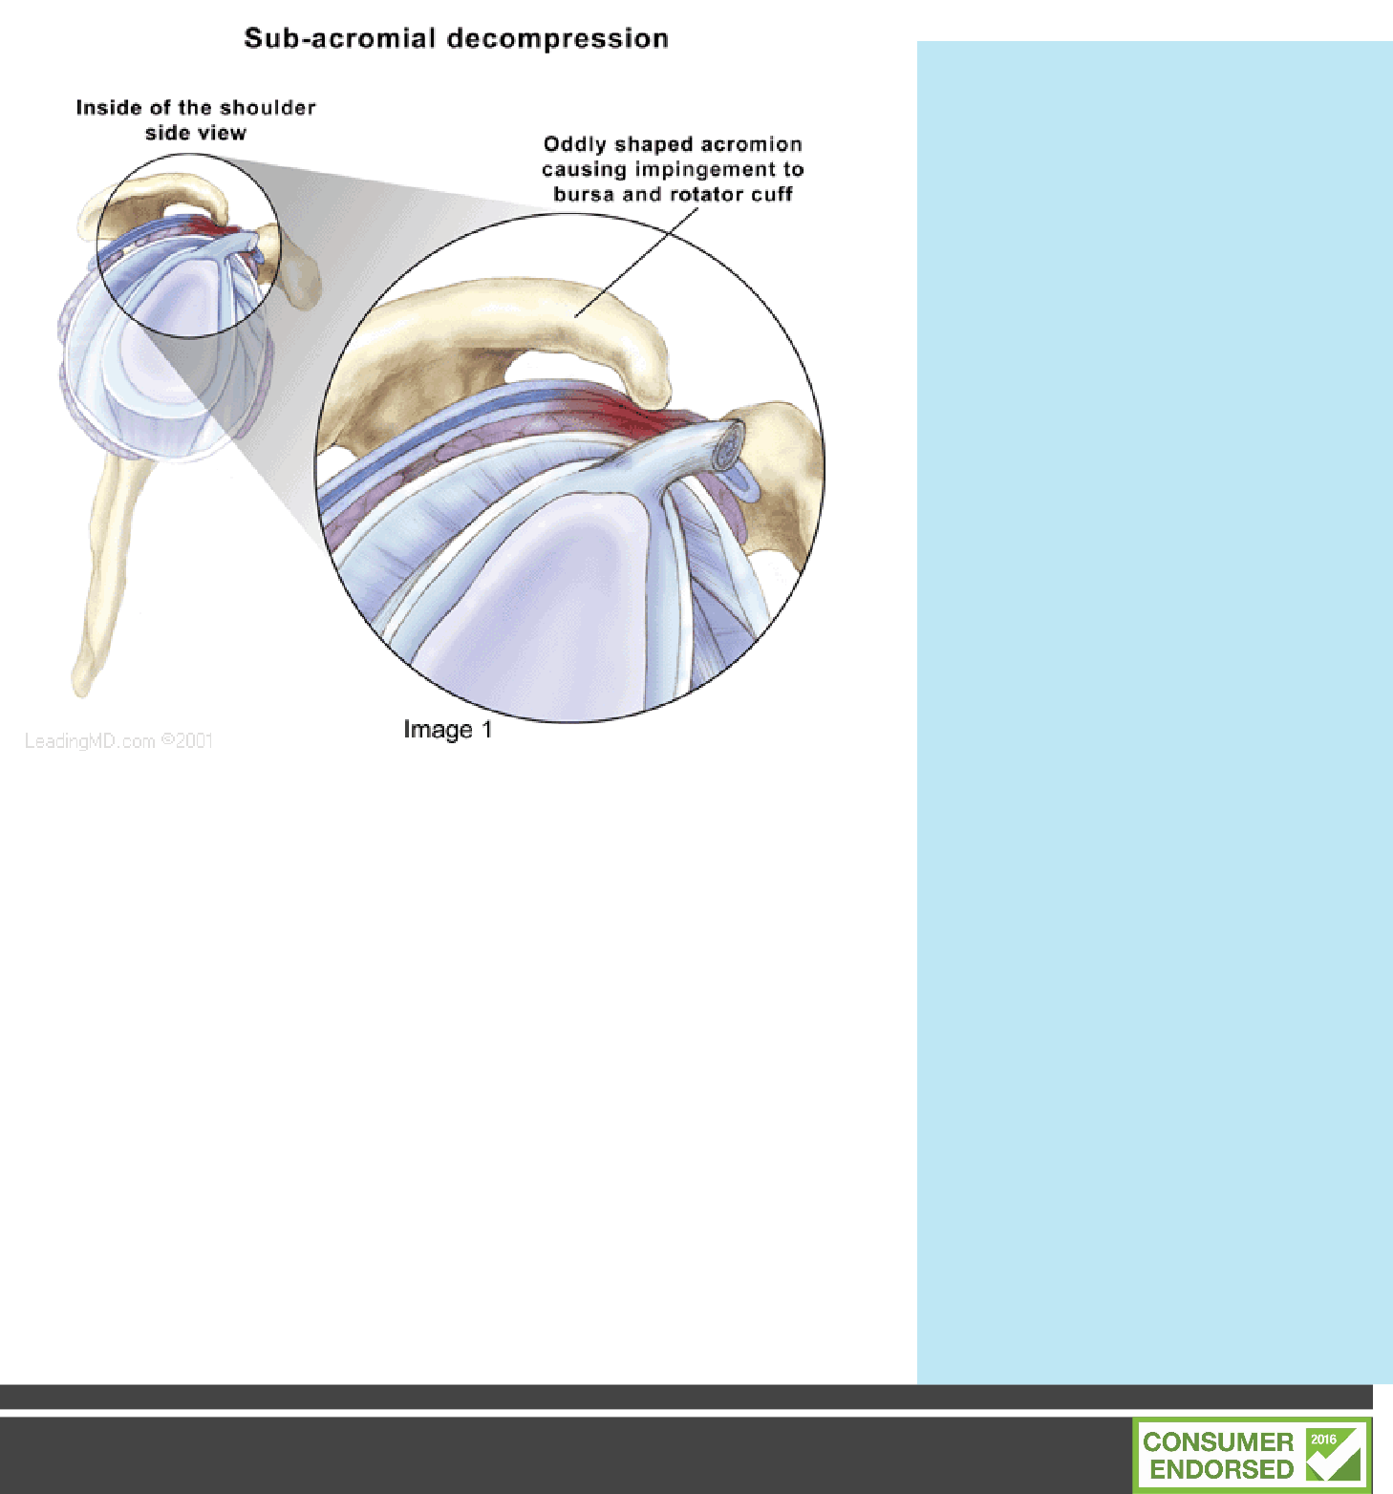
As a person becomes older and uses the shoulder, normal w e a r a n d t e a r , o r degeneration, of the cartilage takes place in the Acromio Clavicular joint which is where the collar bone joins the shoulder blade at the top of the shoulder. There is a loss of cartilage and, over time, the joint can wear out, become larger, and develop spurs (spiny projections from the bone) around the joint. This degeneration results in a c o n d i t i o n k n o w n a s osteoarthritis. Similar to arthritis in other joints of the body, there is pain and swelling in the joint as it is used. AC joint arthritis— o s t e o a r t h r i t i s o f t h e acromioclavicular joint—is common in middle age.
The operation aims to remove the painful and damaged Acromioclavicular Joint using s m a l l b u r r s w i t h o u t destabilising the joint by disrupting the ligaments. As the joint heals, new fibrocartilage develops and shoulder function returns to normal.

Time off work depends upon the type of procedure and the job that you do. Most patients return to sedentary work after a couple of weeks. Getting to and from work will be harder than you think and your shoulder will be easily irritated. Your Specialist and Physio will be able to guide you with this.
Dressings

The incisions are usually closed with small tapes and additional s t i t c h e s T h e w o u n d s a r e covered with a showerproof dressing.
Your Dressing Protocols for the next 2 weeks is -
Sling
You will have a sling following your surgery. You can come out of the sling for gentle exercising
and showering.

Sleeping

Comfortable sleeping positions can be difficult to find. Generally semi reclined positions work best. Use either lots of pillows or a recliner chair if you have one. So long as the arm is not under p r e s s u r e , w h a t e v e r i s comfortable is the right position.

Showering

possible. Exercises and advice will be given to help get you going and you will be shown how to use your sling. Further rehabilitation in addition to the exercises shown to you in hospital commences at 1-2 w e e k s t o p r o g r e s s y o u r allowable movement. You will require extensive therapy to get the most from your operation. You must not initially use heavy weights or resistance with your a r m . Y o u r S u r g e o n o r Physiotherapist will be able to guide you on time frames regarding this.
Please call the Physiotherapist on 9815 2555 if you have any queries.

Complications

You can shower after
days.
Shoulder Surgery is generally a

Review
You should have an appointment made 1-2 weeks following your surgery. Physiotherapy may start after this.

Driving

This will vary greatly depending upon your circumstances. Your surgeon will discuss with you time frames for driving.

Activities

Unless otherwise instructed you should not take weight through your arm. You can move or hold the arm by itself, but be careful of not doing too much. Getting dressed, thread your operated arm through your sleeve first and off last. Button up shirts or loose t shirts are best.
T h e r e i s a s h o w e r p r o o f dressing over your wound. To wash under your arm, lean forward and let the hand dangle, you can then use your other arm to access your armpit.

Medication

Yo u will be provided with medication upon your departure f rom hospital. Follow the instructions as described to you by your nurse. As a general rule, your medication requirements should continue to decrease over the early post-operative period.
Remember if you are using codeine based products that constipation can be an issue so keep up the water and a fibre b a s e d p r o d u c t s u c h a s Metamucil/ Coloxyl can be of assistance.

Physiotherapy

Y o u w i l l b e s e e n b y a physiotherapist whilst in hospital at the request of your surgeon (for uninsured patients there will be a small fee for this) to ensure your recovery is as quick as
v e r y s a f e p r o c e d u r e a n d
complications are uncommon, however despite the highest s u r g i c a l s t a n d a r d s a n d precautions they can occur. Potential serious problems include infection and vein thrombosis (blood clots). An onset of fevers or sweats, or i n c r e a s i n g r e d n e s s a n d discharge from or around the wound can indicate that an infection is present. Please call if this occurs.

If you experience fevers, persistent swelling or bleeding or unusual pain in the arm or calf you should call the ward on 9009 3800 or contact your surgeon or attend to your GP or nearest hospital emergency department.

You may also experience numbness in the elbow or arm due to minor nerve damage which is normal with surgery. This can take months to resolve.

All information in this brochure is a guide and is the opinion of Glenferrie Private Hospital

Reviewed 1.9.19

