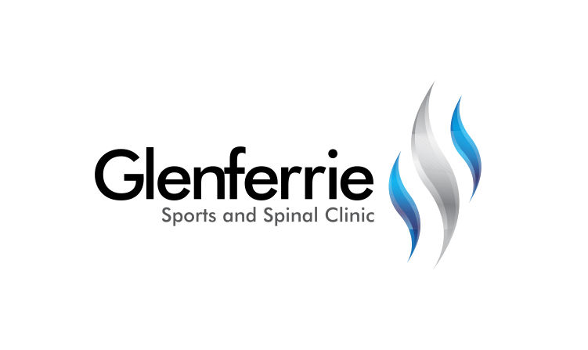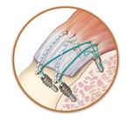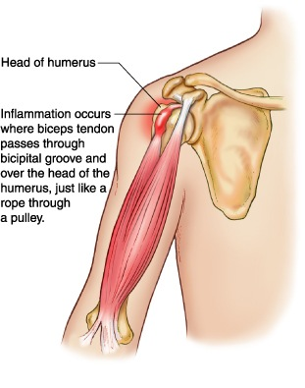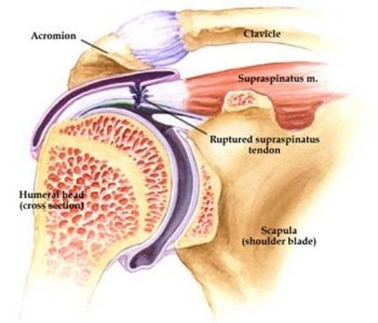

[Editable section]

**Your clinic logo**

[Editable section]

Your clinic’s details

**[phone]**

Physiotherapy

Hand Therapy

Podiatry

Massage

Naturopath

**9815 2555**

Rotator Cuff Repair surgery can either be performed arthroscopically (keyhole surgery via small incisions) or via an open procedure in which a larger incision is made. The surgery seeks to repair the torn tendon. The surgery uses small sutures and rivets (called suture anchors) to repair the tendon so that it once again attaches firmly to bone.

# Rotator Cuff Tear

The rotator cuff is a critical group of muscles and tendons that form a cuff over the shoulder. Their primary role is to keep the head of your upper arm bone firmly in the shallow socket of your shoulder blade. If these muscles or tendons become worn or torn, you may experience pain, weakness, and an inability to fully raise your arm.

Depending on the size and location of the tear, conservative treatment (physiotherapy) can sometimes be effective. If the tear is of a certain dimension or location, surgery may be required.

Biceps Tenodesis

The biceps are a muscle that travels from the elbow to the shoulder at the front of the upper arm. When you bend your elbow, the muscle tone that develops in the front of your upper arm is your bicep muscle. The bicep attaches into your shoulder via a tendon. Due to repetitive use or an acute injury, this tendon can develop inflammation, small tears, or a complete detachment from the shoulder socket.

A Biceps Tenodesis is a surgical procedure which relocates the bicep tendon. It involves cutting the bicep tendon from its usual attachment into the shoulder socket and relocating and reattaching the tendon to the upper arm bone (humerus).

# Treatment

The shoulder is actually composed of more than a single joint. It is better understood as a ‘complex’, composed of a number of different structures.

1. The shoulder blade (scapula)
2. The collar bone (clavicle)
3. The arm bone (humerus)
4. The joints that link each of these structures together

Treatment for shoulder conditions first requires the correct diagnoses. Upon assessment, further investigations may be required such as an xray or scan (such as an ultrasound or MRI), to assist with confirmation.

9815 2555

Glenferrie Sports and Spinal

**Physiotherapy**

Matthew Hopkinson

Sarah Forsyth

Kseniya Vasyanska

*Emily Lam*

**Hand Therapy**

Hamish Anderson

**Podiatry**

Ben Holland

Ryan Cornwall

**Massage**

Jacqueline Stavridis

Leigh Baker

**Naturopath and Nutrition**

Anna Boetto

In order to reach with your arm, particularly above shoulder height, each of the joints that contribute to the shoulder ‘complex' must work as a team. Soft tissues (muscles, tendons, ligaments) have a large role to play in facilitating this ‘teamwork’. Where there is a deficit in any of these tissues, pain and movement limitations can result.

# Conservative Treatment

Through a progressive, gentle range-of-motion and strengthening program, the shoulder dysfunction will generally resolve. Exercises will be based upon re-educating the muscles of the neck, shoulder, and thorax so they work in unison to provide the necessary control to guide the shoulder through the activity.

Postural advice is often included, as this can be a major factor in shoulder dysfunction. In a world where we sit and work with technology, bad habits too often lead to injuries. Occasionally, shoulder and arm pain can originate from the neck or upper back. The therapist will be able to assess and treat this should it be contributing to the problem.

Alternative therapies such as remedial massage can help to relieve the tensions of the shoulder, neck, and back that may be contributing to pain and discomfort. Headaches and loss of sleep are common side effects to shoulder dysfunction due to stresses on other parts of the body because of the shoulder.

Shoulder injuries generally take a long time to get better, especially if there is a tendon injury. Your clinician will guide you through a timeline but be patient as it can take 6 months or more.

# Surgical Treatment

When tissues are damaged through injury or natural age-related ‘wear and tear’, some have a natural ability to heal. Other tissues, however, have a poor healing capacity and surgery may be required to reduce pain, restore movement, and enable a return to home, work, and leisure activities.

In some circumstances, tissues simply need to be trimmed or ‘tidied up’ to reduce irritation and improve comfort. In other circumstances, tissues need to be repaired.

Shoulder surgery can be performed either arthroscopically or via an open procedure.

Arthroscopic shoulder surgery is a form of keyhole surgery in which a small telescope attached to a video camera is used. An open procedure involves a larger incision in the skin to gain access to the tissues which require repair.

In the majority of cases, an arthroscopic surgical technique can be used. In some instances, however, your surgeon may need to utilise an ‘open procedure’.

Depending upon the quality of your tendons and the type of operation performed, you may be required to protect your arm for up to 6 weeks post-surgery. You will then commence a progressive range-of-movement and strengthening program much like you would do with a conservative program. Recovery from shoulder surgery can take 6 to 12 months depending upon the procedure performed.

*All information in this brochure is a guide and is the opinion of GSSC