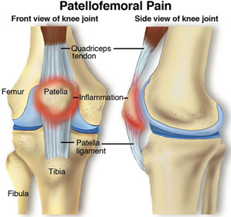

Physiotherapy

Hand Therapy

Podiatry

Massage

Naturopath

**9815 2555**

[Editable section]

Your clinic’s details

**[phone]**

[Editable section]

**Your clinic logo**

# Patella Femoral Dysfunction

Patellofemoral dysfunction refers to pain that originates in the patellofemoral joint (between the kneecap and the thigh bone). It is common and is also referred to as “Anterior Knee Pain”. It may occur spontaneously, although is not infrequently seen after a traumatic injury to the knee. The characteristic pain persists after the initial symptoms of the injury resolve. It may also occur after knee surgery. Although it may occur at any age, teenage females are the most commonly affected. There are a number of factors that contribute to patellofemoral dysfunction.  The pain comes from the kneecap moving abnormally in the groove on the thigh bone. This causes increased forces on the joint and results in pain.

Factors that contribute include weakness of the thigh muscles, tightness of the muscles on the outer aspect or back of the thigh, and flat feet. The main symptom is pain which usually starts gradually and progressively worsens over time, often without any history of injury. Pain is localised under or around the kneecap or the inside aspect of the knee. It is worse when walking downstairs, with prolonged sitting, or when first getting up from a chair. Clicking or grinding of the kneecap is often present. Both knees may be affected. In its extreme form, patellofemoral dysfunction can lead to a dislocation of the knee cap.

Tendinophathy

Patella tendonosis is inflammation of the patellar tendon. The patella tendon (ligament) is the structure which runs from below the kneecap (patella) to the shin bone (tibia), and its function is to straighten the knee in activities such as jumping, walking, and running.

Although this is a common condition, the cause is not known. It can affect anyone, but it is common in athletes who put large forces through their patella tendon through activity such as jumping; this condition was once known as jumper’s knee. It can also occur in runners. Poor flexibility in the thigh muscles (quadriceps) and hamstrings, and a raised kneecap (patella alta) are thought to increase the forces though the patella tendon and increase the risk of patella tendonosis. Another theory is that repeated stress on the tendon causes the tendon to be damaged faster than the tendon can be repaired.

Patients complain of pain along the tendon which may feel sharp, particularly after running or jumping. The pain can persist after exercise as a dull ache. The patella tendon becomes tender to touch.

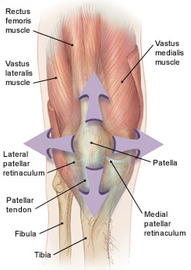

# Treatment

The knee is actually composed two joints. A number of structures surround the area and can all affect the knee. A holistic approach is therefore beneficial to managing knee injuries.

Treatment for knee problems first requires the correct diagnoses. Upon assessment, further investigations may be required such as an xray or scan (such as an ultrasound or MRI), to assist with confirmation.

9815 2555

Glenferrie Sports and Spinal

**Physiotherapy**

Matthew Hopkinson

Sarah Forsyth

Kseniya Vasyanska

*Emily Lam*

**Hand Therapy**

Hamish Anderson

**Podiatry**

Ben Holland

Ryan Cornwall

**Massage**

Jacqueline Stavridis

Leigh Baker

**Naturopath and Nutrition**

Anna Boetto

# Conservative Treatment

Patellofemoral dysfunction is best treated non-surgically. Physiotherapy is the mainstay of treatment. The aim of physiotherapy is to assist in strengthening the thigh muscles, stretching the tight soft tissues, and correcting other factors above and below the knee that contribute to the condition. The knee may be taped into the correct position to assist the kneecap to move more efficiently in the groove on the thigh bone. While this physiotherapy program is very effective, it needs to be followed diligently for full recovery which may take more than 6 weeks.

Tendinopathies are managed with a progressive eccentric loading exercise program under the supervision of the physiotherapist. This can often take months of careful activity.

Other non-surgical treatments include ice packs and anti-inflammatory medications to treat the symptoms of swelling and inflammation.

The goal of treatment is a return to a desired level of activity without pain. Most patients need to refrain from activities that exacerbate the knee pain until strength and flexibility have improved. As symptoms resolve, return to normal sports is encouraged.

Injections may be recommended to help reduce the inflammation of the irritated structures and facilitate the healing processes if progression is slow.

# Operative Treatment

In rare cases, conservative treatment will not be sufficient to alleviate symptoms and surgical options may be considered. In cases where the kneecap continues to dislocate, an operation to release a tendon on the outside of the knee may be combined with other procedures to improve knee stability. Rehabilitation following is much the same as conservative management and involves strengthening and stretching the muscles in the thigh to promote control and reduce unnatural forces through the joint.

*All information in this brochure is a guide and is the opinion of GSSC