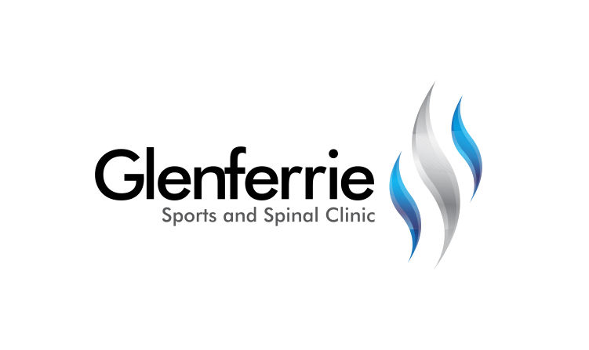Image

Physiotherapy

Hand Therapy

Podiatry

Massage

Naturopath

**9815 2555**

[Editable section]

Your clinic’s details

**[phone]**

[Editable section]

**Your clinic logo**

Haematoma

Athletes in all contact sports are at risk of sustaining a “corky” – otherwise known medically as a muscle contusion (bruise). Contusions are second only to strains as a leading cause of sports injuries.

The majority of contusions are minor and heal really quickly without taking the athlete away from the game. But severe contusions can cause deep muscle damage and can lead to complications that may keep the athlete out of sports for months.

Contusions occur when there is a direct blow or repeated blows from a blunt object that strikes part of the body, crushing underlying muscle fibres and connective tissue without breaking the skin.

A contusion can result from falling or jamming the body against a hard surface, such as an opposition player’s knee.

Contusions cause pain and swelling as well as limited joint range-of-motion around the injury.  The direct blow causes blood vessel damage, with the torn blood vessels leaking out a bluish discolouration. The injured muscle may feel weak and stiff.

Sometimes, a pool of blood collects within damaged tissue, forming a painful lump in the area of the injury (haematoma).

# Muscle Tear

Sore muscles and muscle aches are a common symptom post-exercise. However, when you hear reports of muscle spasms, muscle strain, pulled muscle, or a torn muscle, then there has been significant muscle injury. Muscle pain, no matter how you describe it -  "pulled muscle", "muscle strain", "muscle injury", or "torn muscle"- the end result is injury to your muscle, potentially resulting in muscle spasms, pain, weakness, and reduced muscle performance. Muscle pain can be caused by any muscle strain, injury, or tear. The most common are the high speed and load muscles such as your hamstrings, thigh (quadriceps), calf, back, and biceps. Muscle tears can range from a mild strain (grade one), moderate strain (grade two) to a severe strain or complete rupture (grade three). Strains most commonly occur in the:

* Lower back
* Neck
* Shoulder
* Hamstring muscle, which is located in the back of the thigh, and
* Calf muscle

Image

9815 2555

Glenferrie Sports and Spinal

**Physiotherapy**

Matthew Hopkinson

Sarah Forsyth

Kseniya Vasyanska

*Emily Lam*

**Hand Therapy**

Hamish Anderson

**Podiatry**

Ben Holland

Ryan Cornwall

**Massage**

Jacqueline Stavridis

Leigh Baker

**Naturopath and Nutrition**

Anna Boetto

**Diagnosing and treating a muscle strain**

* Alleviate pain and inflammation
* Reduce the risk of further injury
* Regain full use of your body
* Give your body a chance to rest and heal properly

Without proper treatment, you may experience recurring injuries or pain and weakness in the muscle during everyday use. It can be especially painful during exercise and athletic activities.

Surgery is necessary to repair a muscle that is torn as opposed to one that is strained. Surgery is typically the last resort for muscle injuries.

**RICE Method**

The individual letters of RICE stand for Rest, Ice, Compression, and Elevation. RICE involves the following:

*Rest* by taking an adequate amount of time to heal and avoiding physical activity. This can help strained muscles and other injuries.

*Ice* your muscle by using cold packs with a barrier between them and your skin four to eight times per day for 20 minutes at a time.

*Compress* your muscle by applying a steady, gentle pressure on it. This prevents swelling and inflammation which delays healing. Wrapping an elastic bandage around the affected muscle is best.

*Elevate* the injury above your heart to reduce swelling. Use pillows or other devices to raise an affected limb while you rest.

*Anti-inflammatory* pain relievers such as ibuprofen (Nurofen) or aspirin can help reduce swelling and pain.

*Physiotherapy* may also be needed. They will be able to massage the area to relieve pain as well as prescribe stretching and strengthening exercises in a timely manner to return you to normal activities without re-injury.

Surgery is the typical treatment for torn or ruptured muscles. You and your doctor will discuss all surgical or nonsurgical options available to repair your muscle.

The last thing you want to do is re-injure a strained muscle. There are several ways you can prevent a muscle strain from recurring, including:

* Allowing for proper time to heal from an injury
* Stretching your muscles daily
* Cross-training for sports by weightlifting or choosing another activity to strengthen your muscles
* Warming up before exercise or intense activity
* Eating foods high in potassium, like bananas and avocados, before exercise to prevent muscle fatigue
* Properly hydrating during exercise

*All information in this brochure is a guide and is the opinion of GSSC