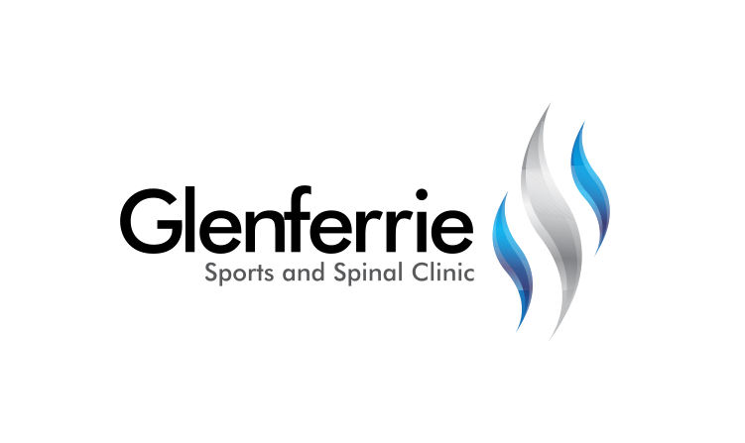Image

[Editable section]

**Your clinic logo**

[Editable section]

Your clinic’s details

**[phone]**

Physiotherapy

Hand Therapy

Podiatry

Massage

Naturopath

**9815 2555**

# Back Pain

Eighty percent (80%) of people will experience lower back pain at some stage of their life. It is one of the most common reasons for people missing work and seeing a doctor or physiotherapist. But lower back pain is something you can avoid with some inside knowledge, back care strategies, and some back exercises. However, if you choose to neglect your back care, you can be rendered vulnerable to lower back pain, sciatica (leg pain), or other nerve pain from a pinched nerve. Long-term lower back pain can result in permanent conditions such as spinal stenosis or degenerative disc disease.

Significant acute lower back pain can result from a herniated disc (slipped disc), back muscle pain, back ligament strain, or a non-specific lower back pain. You can also suffer lower back pain associated with systemic conditions such as fibromyalgia, rheumatoid arthritis, or ankylosing spondylitis.

As you can see, while lower back pain is common, the diagnosis is specific to you and is best cared for with the assistance of spinal healthcare such as a physiotherapist. Not only can they assist you with acute back pain relief, they can also help you on your way to long-term self-management and prevention. This usually includes a thorough back assessment to determine risk factors such as muscle weakness, inflexibility, and stiff or unstable joints. They can also advise you when a back brace is suitable or if it is better to perform some specific back exercises.

Posture

Poor posture can cause a range of problems including back pain, spinal problems, poor circulation, joint degeneration, and rounded shoulders.

Good posture can help relieve back pain and involves training your body to function in positions where the least amount of strain is placed on supporting muscles and ligaments.

When improving your posture, your physiotherapist will work with you to determine the cause and decide on a course of treatment.

Poor posture can cause problems including:

* Back pain
* Headaches
* Spinal problems
* Muscle fatigue and strain
* Joint degeneration and increased disc problems
* Ligament laxity/stretch
* Rounded shoulders
* Poor circulation

9815 2555

Glenferrie Sports and Spinal

**Physiotherapy**

Matthew Hopkinson

Sarah Forsyth

Kseniya Vasyanska

*Emily Lam*

**Hand Therapy**

Hamish Anderson

**Podiatry**

Ben Holland

Ryan Cornwall

**Massage**

Jacqueline Stavridis

Leigh Baker

**Naturopath and Nutrition**

Anna Boetto

**Back Pain Causes**

Lower back pain has many causes. Most lower back pain causes are musculoskeletal in origin and known as non-specific low back pain. Most commonly, these back injuries are caused by muscular strains, ligament sprains, and joint dysfunction, particularly when pain arises suddenly during or following physical loading of the spine.

The good news is that you can take measures to prevent or lessen most back pain episodes. Your physiotherapist is an expert who treats and can help you to prevent low back pain.

Early diagnosis and treatment are the easiest ways to recover quickly from lower back pain and to prevent recurrence. The causes of lower back pain are numerous but roughly fall into either sudden (traumatic) or sustained overstress injuries. Most people can relate to traumatic injury such as bending awkwardly to lift a heavy load that tears or damages structures. However, sustained overstress injuries are probably more common but also easier to prevent.  In these cases, normally positional stress or postural fatigue creates an accumulated microtrauma that overloads your lower back structures over an extended period of time to cause injury and back pain.

**Common Lower Back Pain Causes**

*Back Muscle Strains*

Back muscle injuries are the most common form of back injury. Muscle fatigue, excessive loads, or poor lifting postures are the most common problems. Inefficient back muscles can lead to poor joint stabilisation and subsequent injury.

*Ligament Sprains*

Ligaments are the strong fibrous bands that limit the amount of movement available at each spinal level. Stretching ligaments too far or too quickly will tear them with subsequent bleeding into the surrounding tissues, causing swelling and pain. Awkward lifting, sports injuries, and motor vehicle accidents are very common causes. Just as in other regions of the body, physiotherapy hastens ligament healing and relieves pain so that you can enjoy life again as soon as possible.

*Bulging Discs*

A bulging disc injury is a common spinal injury sustained to your spine's intervertebral disc. Spinal discs are the shock-absorbing rings of fibrocartilage and glycoprotein that separate your bony vertebral bodies, while allowing movement at each spinal level and enough room for the major spinal nerves to exit from the spinal canal and travel to your limbs.

The annulus is the outer section of the spinal disc. It consists of several layers of multi-directional fibrocartilaginous fibres all densely packed to create a wall around the glycoprotein-filled jelly-like disc nucleus. A disc bulge (commonly referred to as slipped disc), can potentially press against or irritate the nerve where it exits from the spine. This nerve pinch can cause back pain, spasms, cramping, numbness, pins and needles, or pain into your legs.

*Bone Injuries*

You can also fracture your spine if the force involved is highlytraumatic or you have low bone density (e.g. osteoporosis).

**Treatment**

Gentle massage, stretching, and strengthening exercises will all help to relieve back pain. Your physiotherapist will guide you through a program to ease your pain and ensure recurrence is unlikely.

*\*All information in this brochure is a guide and is the opinion of GSSC*

*All information in this brochure is a guide and is the opinion of GSSC