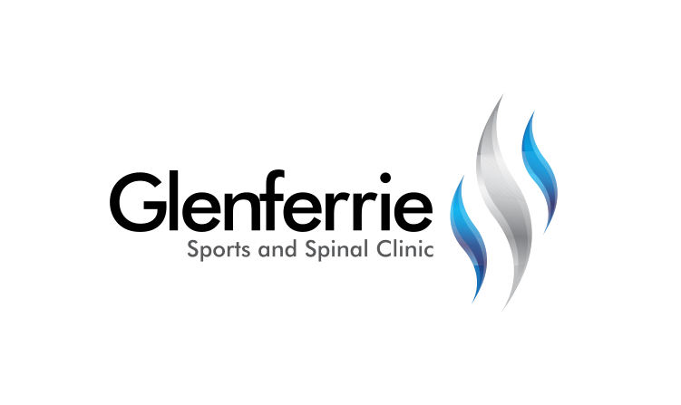Image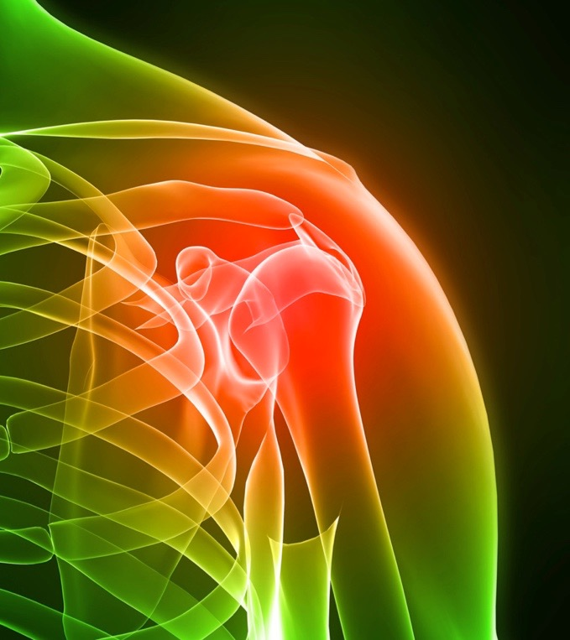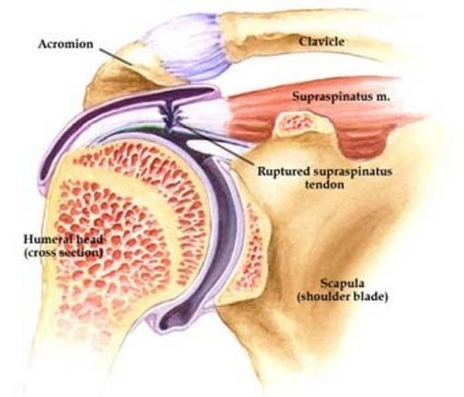

Physiotherapy

Hand Therapy

Podiatry

Massage

Naturopath

**9815 2555**

[Editable section]

Your clinic’s details

**[phone]**

[Editable section]

**Your clinic logo**

Biceps Tenodesis

SLAP tears are one kind of injury which may require surgery, typically in the form of debridement (trimming) or repair. The labrum is a fibrous tissue which encircles the shoulder socket (imagine a rubber ring encircling the top of a golf tee), increasing the stability of the shoulder ‘gleno-humeral’ joint.

Tears of this tissue are typically graded according to their severity as either Type 1, Type 2 or Type 3. Type 1 is a partial tear or degeneration (but not completely detached). Type 2 is a complete tear whereby the labrum is torn off the underlying bone. Type 3 is a ‘bucket handle’’ tear in which the torn labrum may fall into the joint and may cause symptoms of ‘locking’ or ‘clunking’.

# Shoulder Instability

Shoulder instability is a condition in which the shoulder joint (gleno-humeral joint) is too loose, leading to the arm slipping out of the shoulder socket (also known as shoulder dislocation). Instability can occur naturally or as a result of trauma to the shoulder. Damage can occur to a range of different tissues, some of which have a poor natural healing capacity. In the case of traumatic dislocation, cartilage and bone, along with the shoulder capsule and ligament tissue, can be damaged. Whilst rest and immobilisation may assist in the shoulder discomfort settling down, damaged tissues may fail to provide support to the shoulder and further dislocations may occur. This is especially so if the patient performs throwing activities or risks landing on an outstretched arm.

# Treatment

The shoulder is actually composed of more than a single joint. It is better understood as a ‘complex’, composed of a number of different structures.

1. The shoulder blade (scapula)
2. The collar bone (clavicle)
3. The arm bone (humerus)
4. The joints that link each of these structures together

Treatment for shoulder instability first requires the correct diagnoses. Upon assessment, further investigations may be required such as an xray or scan (such as an ultrasound or MRI) to assist with confirmation.

9815 2555

Glenferrie Sports and Spinal

**Physiotherapy**

Matthew Hopkinson

Sarah Forsyth

Kseniya Vasyanska

*Emily Lam*

**Hand Therapy**

Hamish Anderson

**Podiatry**

Ben Holland

Ryan Cornwall

**Massage**

Jacqueline Stavridis

Leigh Baker

**Naturopath and Nutrition**

Anna Boetto

In order to reach with your arm, particularly above shoulder height, each of the joints that contribute to the shoulder ‘complex’ must work as a team. Soft tissues (muscles, tendons, ligaments) have a large role to play in facilitating this ‘teamwork’. Where there is a deficit in any of these tissues, pain and movement limitations can result.

# Conservative Treatment

Following a dislocation, a period of immobilisation is required to let torn tissues heal and tighten.

Following this, a progressive gentle range-of-motion and strengthening program can commence to help resolve the dysfunction. Exercises will be based upon re-educating the muscles of the neck, shoulder, and thorax so they work in unison to provide the necessary control to guide the shoulder through the activity.

Strengthening and proprioception exercises are important to assist the shoulder to function and reduce the risk of re-injury.

Postural advice is often included, as this can be a major factor in the shoulder dysfunction. In a world where we sit and work with technology, bad habits too often lead to injuries. Occasionally, shoulder and arm pain can originate from the neck or upper back. The therapist will be able to assess and treat this should it be contributing to the problem.

Alternative therapies such as remedial massage can help to relieve the tensions of the shoulder, neck, and back that may be contributing to pain and discomfort. Headaches and loss of sleep are common side effects to shoulder dysfunction due to stresses on other parts of the body because of the shoulder.

Shoulder injuries generally take a long time to get better, especially if there is a tendon injury. Your clinician will guide you through a timeline but be patient as it can take 6 months or more.

# Surgical Treatment

Occasionally, tissues have a poor healing capacity and surgery may be required to reduce pain, restore movement, and enable a return to home, work, and leisure activities.

In some circumstances, tissues simply need to be trimmed or ‘tidied up’ to reduce irritation and improve comfort. In other circumstances, tissues need to be repaired or reconstructed.

Shoulder reconstructive surgery is performed to re-site damaged tissue to provide joint stability, especially when it is unlikely to occur naturally.

Shoulder surgery can be performed either arthroscopically or via an open procedure.

Depending upon the type of operation performed, you may be required to protect your arm for up to 6 weeks post-surgery. You will then commence a progressive range-of-movement and strengthening program much like you would do with a conservative program. Recovery from shoulder surgery can take 6 to 12 months depending upon the procedure performed.

*All information in this brochure is a guide and is the opinion of GSSC