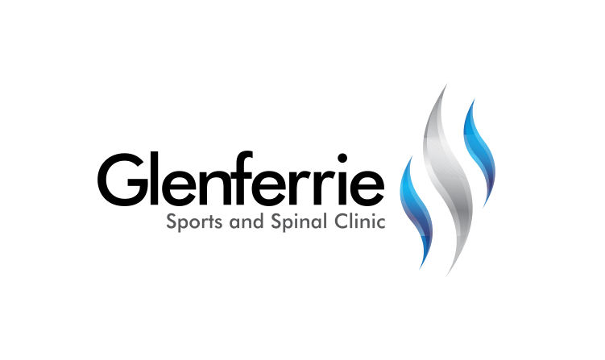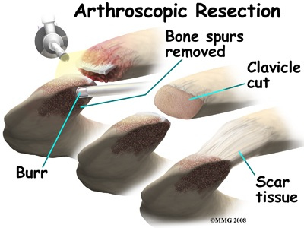

[Editable section]

**Your clinic logo**

[Editable section]

Your clinic’s details

**[phone]**

Physiotherapy

Hand Therapy

Podiatry

Massage

Naturopath

**9815 2555**

AC Joint

The AC (Acromio-clavicular) joint joins the shoulder blade and the collar bone. The AC joint is required to fully raise the arm. As we age, the bones (clavicle and acromion) that make up the AC joint can develop osteoarthritis, leading to pain and impaired shoulder movement.

Typically, the AC joint, when irritated, causes discomfort with movements across the body and behind the back.

Gentle exercise and resting of irritating movements can assist in settling the pain, followed by a progressive strengthening program. If the AC joint does not respond to treatment, an injection can be beneficial.

The AC Joint is an unusual joint in that it is a fibrocartilagenous joint. This means that it can respond very well to surgery.

# Shoulder Impingement

As we age, bone spurs (bone growth) can develop on a part of the shoulder blade called the acromion. This can then cause irritation to other tissues of the shoulder. One such tissue is called a bursa, which is a small fluid-filled sack (imagine a small water balloon). Repetitive irritation of the bursa can lead to a condition called bursitis (inflamed bursa). The inflamed bursa or the bone spur can further irritate tendons which pass through the area, leading to tendon swelling and ‘wear and tear’.

Posture plays a big role in shoulder dysfunction. Modern society revolves around a lot of desk-bound and mobile technologies. Combined with relaxation activities, the rounded posture that evolves puts a lot of pressure on the shoulder complex, closing down the space through which the tendons run. In addition to exercises for the arm, exercises for the shoulder blade and back are really important to assist with recovery and prevent the return of pain.

# Treatment

The shoulder is actually composed of more than a single joint. It is better understood as a ‘complex’, composed of a number of different structures.

1. The shoulder blade (scapula)
2. The collar bone (clavicle)
3. The arm bone (humerus)
4. The joints that link each of these structures together

Treatment for shoulder instability first requires the correct diagnoses. Upon assessment, further investigations may be required such as an xray or scan (such as an ultrasound or MRI) to assist with confirmation.

9815 2555

Glenferrie Sports and Spinal

**Physiotherapy**

Matthew Hopkinson

Sarah Forsyth

Kseniya Vasyanska

*Emily Lam*

**Hand Therapy**

Hamish Anderson

**Podiatry**

Ben Holland

Ryan Cornwall

**Massage**

Jacqueline Stavridis

Leigh Baker

**Naturopath and Nutrition**

Anna Boetto

In order to reach with your arm, particularly above shoulder height, each of the joints that contribute to the shoulder ‘complex’ must work as a team. Soft tissues (muscles, tendons, ligaments) have a large role to play in facilitating this ‘teamwork’. Where there is a deficit in any of these tissues, pain and movement limitations can result.

# Conservative Treatment

Following an acute or chronic injury to the shoulder, rest and, occasionally, immobilisation is required. Following this, a progressive gentle range-of-motion and strengthening program can commence to help resolve the dysfunction. Exercises will be based upon re-educating the muscles of the neck, shoulder, and thorax so they work in unison to provide the necessary control to guide the shoulder through the activity.

Strengthening and proprioception exercises are important to assist the shoulder to function and reduce the risk of re-injury.

Postural advice is often included, as this can be a major factor in the shoulder dysfunction. In a world where we sit and work with technology, bad habits too often lead to injuries. Occasionally, shoulder and arm pain can originate from the neck or upper back. The therapist will be able to assess and treat this should it be contributing to the problem.

Alternative therapies such as remedial massage can help to relieve the tensions of the shoulder, neck, and back that may be contributing to pain and discomfort. Headaches and loss of sleep are common side effects to shoulder dysfunction due to stresses on other parts of the body because of the shoulder.

Shoulder injuries generally take a long time to get better, especially if there is a tendon injury. Your clinician will guide you through a timeline but be patient as it can take 6 months or more.

# Surgical Treatment

Occasionally, tissues have a poor healing capacity and surgery may be required to reduce pain, restore movement, and enable a return to home, work, and leisure activities.

In some circumstances, tissues simply need to be trimmed or ‘tidied up’ to reduce irritation and improve comfort. In other circumstances, tissues need to be repaired or reconstructed.

Shoulder reconstructive surgery is performed to re-site damaged tissue to provide joint stability, especially when it is unlikely to occur naturally.

Shoulder surgery can be performed either arthroscopically or via an open procedure.

Depending upon the type of operation performed, you may be required to protect your arm for up to 6 weeks post-surgery. You will then commence a progressive range-of-movement and strengthening program much like you would do with a conservative program. Recovery from shoulder surgery can take 6 to 12 months depending upon the procedure performed.

*All information in this brochure is a guide and is the opinion of GSSC