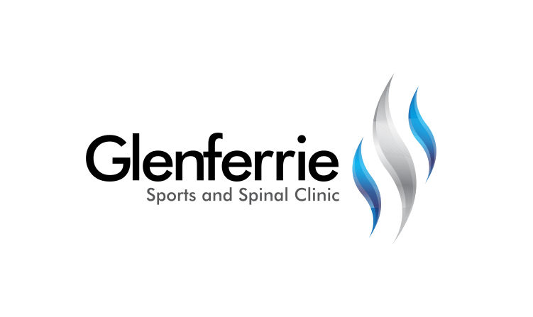Image

Physiotherapy

Hand Therapy

Podiatry

Massage

Naturopath

**9815 2555**

[Editable section]

Your clinic’s details

**[phone]**

[Editable section]

**Your clinic logo**

# Frozen Shoulder

Frozen shoulder, also known as adhesive capsulitis, is a condition characterised by stiffness and pain in your shoulder joint. Signs and symptoms typically begin gradually, worsen over time, and then resolve, usually within one to three years.

Frozen shoulder occurs when this capsule thickens and tightens around the shoulder joint, restricting its movement.

Doctors are not sure why this happens to some people, although it is more likely to occur in people who have diabetes or those who recently had to immobilise their shoulder for a long period, such as after surgery.

Treatment for frozen shoulder involves range-of-motion exercises best performed after corticosteroids and numbing medications which are injected into the joint capsule in a procedure called a hydrodilatation. In a small percentage of cases, arthroscopic surgery may be indicated to loosen the joint capsule so that it can move more freely.

It is unusual for frozen shoulder to recur in the same shoulder, but some people can develop it in the opposite shoulder.

Arthritis

Simply defined, arthritis is inflammation of one or more of your joints. In a diseased shoulder, inflammation causes pain and stiffness.

Although there is no cure for arthritis of the shoulder, there are many treatment options available. Using these, most people with arthritis are able to manage pain and stay active. Gentle exercise and resting of irritating movements can assist in settling the pain, followed by a progressive strengthening program.

The most common symptom of arthritis of the shoulder is pain, which is aggravated by activity and progressively worsens.

If the glenohumeral shoulder joint is affected, the pain is centered in the back of the shoulder and may intensify with changes in the weather. Patients complain of an ache deep in the joint.

The pain of arthritis in the acromioclavicular (AC) joint is focused on the top of the shoulder. This pain can sometimes radiate or travel to the side of the neck.

Someone with rheumatoid arthritis may have pain throughout the shoulder if both the glenohumeral and AC joints are affected.

# Treatment

The shoulder is actually composed of more than a single joint. It is better understood as a ‘complex’, composed of a number of different structures.

1. The shoulder blade (scapula)
2. The collar bone (clavicle)
3. The arm bone (humerus)
4. The joints that link each of these structures together

Treatment for shoulder instability first requires the correct diagnoses. Upon assessment, further investigations may be required such as an xray or scan (such as an ultrasound or MRI) to assist with confirmation.

9815 2555

Glenferrie Sports and Spinal

**Physiotherapy**

Matthew Hopkinson

Sarah Forsyth

Kseniya Vasyanska

*Emily Lam*

**Hand Therapy**

Hamish Anderson

**Podiatry**

Ben Holland

Ryan Cornwall

**Massage**

Jacqueline Stavridis

Leigh Baker

**Naturopath and Nutrition**

Anna Boetto

In order to reach with your arm, particularly above shoulder height, each of the joints that contribute to the shoulder ‘complex’ must work as a team. Soft tissues (muscles, tendons, ligaments) have a large role to play in facilitating this ‘teamwork’. Where there is a deficit in any of these tissues, pain and movement limitations can result.

# Conservative Treatment

Following an acute or chronic injury to the shoulder, rest and, occasionally, immobilization is required. Following this, a progressive gentle range-of-motion and strengthening program can commence to help resolve the dysfunction. Exercises will be based upon re-educating the muscles of the neck, shoulder, and thorax so they work in unison to provide the necessary control to guide the shoulder through the activity.

Strengthening and proprioception exercises are important to assist the shoulder to function and reduce the risk of re-injury.

Postural advice is often included, as this can be a major factor in the shoulder dysfunction. In a world where we sit and work with technology, bad habits too often lead to injuries. Occasionally, shoulder and arm pain can originate from the neck or upper back. The therapist will be able to assess and treat this should it be contributing to the problem.

Alternative therapies such as remedial massage can help to relieve the tensions of the shoulder, neck, and back that may be contributing to pain and discomfort. Headaches and loss of sleep are common side effects to shoulder dysfunction due to stresses on other parts of the body because of the shoulder.

Shoulder injuries generally take a long time to get better, especially if there is a tendon injury. Your clinician will guide you through a timeline but be patient as it can take 6 months or more.

# Surgical Treatment

Occasionally, tissues have a poor healing capacity and surgery may be required to reduce pain, restore movement, and enable a return to home, work, and leisure activities.

In some circumstances, tissues simply need to be trimmed or ‘tidied up’ to reduce irritation and improve comfort. In other circumstances, tissues need to be repaired or reconstructed.

Shoulder surgery can be performed either arthroscopically or via an open procedure.

Generally, when you have a release or clean-up surgery, you are allowed to move your shoulder as you feel comfortable over the ensuing weeks from your operation. You will then commence a progressive range-of-movement and strengthening program much like you would do with a conservative program. Recovery from shoulder surgery can take 6 to 12 months depending upon the procedure performed.

*All information in this brochure is a guide and is the opinion of GSSC