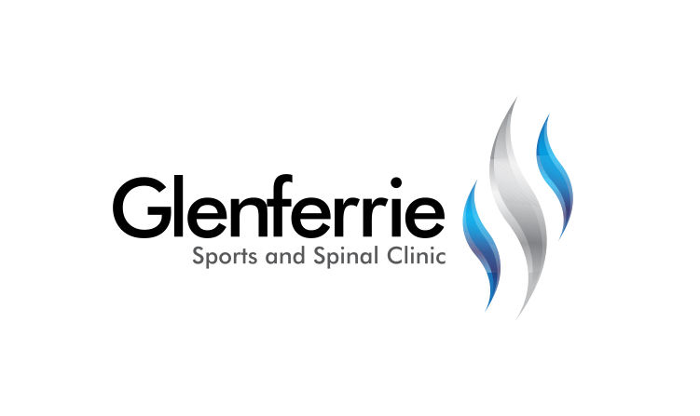Image

[Editable section]

**Your clinic logo**

[Editable section]

Your clinic’s details

**[phone]**

Physiotherapy

Hand Therapy

Podiatry

Massage

Naturopath

**9815 2555**

# FemeroAcetabular Impingement (FAI)

Femoroacetabular impingement or FAI is a condition of too much friction in the hip joint. Basically, the ball (femoral head) and socket (acetabulum) rub abnormally, creating damage to the hip joint. The damage can occur to the articular cartilage (smooth surface of the ball or socket) or the labral cartilage (soft tissue bumper of the socket). FAI is a leading cause for the development of osteoarthritis, particularly in men.

An abnormality in the shape of the hip joint bones may be present at birth or may develop in early childhood after some childhood hip conditions. In most cases, the condition has been asymptomatic for many years. The hip becomes painful when there has been enough damage in the joint. The first symptom is usually mild groin discomfort. Once the joint becomes painful, there is usually a gradual deterioration. Reducing activity levels may reduce the symptoms. Symptoms fluctuate according to activity levels and are often made worse by sport and activities which require deep bending of the hip (for example, getting out of a car). Some patients report recurrent ‘groin sprains’ which are typically slow to settle or recur easily. Over time, FAI causes progressive damage to the cartilage on the rim of the hip socket, leading to osteoarthritis. While osteoarthritis develops over a long time, surgical treatment of the abnormality causing FAI may slow or prevent the progression of joint damage and improve symptoms.

Labrum Injury

The acetabular labrum is a ring of cartilage that surrounds the acetabulum (the socket of the hip joint). Its function is to deepen the acetabulum and assist in the stability, lubrication, and sensation of the hip joint. Put simply, it makes it more difficult for the head of the femur to slip out of place (sublux). Acetabular labral tears generally occur in two situations. Tears can occur as a result of traumatic injury to the hip joint. More commonly, however, tears may occur in a labral cartilage which has gradually accumulated damage over time; this is known as a ‘degenerate tear’. Degenerate labral tears develop as a part of hip joint osteoarthritis or may be related to other hip joint disorders; examples include developmental dysplasia or femoro-acetabular impingement (FAI). Patients with acetabular labral tears commonly experience groin pain, which often gets worse with physical activity and positions where the hip is bent, such as deep squatting or rising from a low chair. Symptoms are often present for a long time. Some patients experience ‘mechanical’ symptoms such as catching or unpredictable ‘weakness’ of the hip joint. Patients with a degenerate labral tear may also have associated damage to the adjacent cartilage of the hip joint socket. Sometimes, small cysts form around the hip joint as a result of the tear. Patients who have a structural cause for their degenerate labral tear (such as dysplasia or femoro-acetabular impingement) have an underlying abnormality in the shape of the hip joint which has pre-disposed the labrum to damage.

# Treatment

The hip is actually a ball and socket joint. A number of structures surround the area and can all affect the hip, including the lumbar spine. A holistic approach is therefore beneficial to managing hip injuries.

Treatment for hip problems first requires the correct diagnoses. Upon assessment, further investigations may be required such as an xray or scan (such as an ultrasound or MRI) to assist with confirmation.

9815 2555

Glenferrie Sports and Spinal

**Physiotherapy**

Matthew Hopkinson

Sarah Forsyth

Kseniya Vasyanska

*Emily Lam*

**Hand Therapy**

Hamish Anderson

**Podiatry**

Ben Holland

Ryan Cornwall

**Massage**

Jacqueline Stavridis

Leigh Baker

**Naturopath and Nutrition**

Anna Boetto

# Conservative Treatment

# Many patients with early damage can manage their symptoms without requiring surgery.

# This particularly involves working on the stabilising muscles of the hip and pelvis to control movements and reduce the stress on the hip and pelvis complex.

# For persistent symptoms or significant traumatic injuries, acetabular labral tears can often be successfully treated with hip arthroscopy (keyhole surgery). For patients with a structural abnormality of the hip joint, consideration should be made to correcting the underlying cause for the labral tear.

# Operative Treatment

Surgical treatment depends on the type of FAI and its cause. In the absence of significant arthritis, many patients will benefit from hip arthroscopy (minimally invasive key-hole surgery). Other surgical treatments for FAI include open debridement, femoral osteotomy, and triple pelvic osteotomy. Knowing which procedure is most appropriate for an individual patient requires clinical assessment.

Arthroscopy is key-hole surgery using a pencil-sized fibre-optic camera. It allows safe access into the joint so that the surgeon can accurately assess damage to the joint and perform corrective procedures where required.

Previously, accessing the hip joint required extensive open procedures with large incisions. Hip arthroscopy is a minimally invasive procedure which allows rapid post-operative recovery. It is useful in the treatment of selected hip disorders. Hip arthroscopy can be used to treat the symptoms of pain or catching associated with early damage to the hip joint. It can also be used to treat hip impingement syndrome. It is useful for the accurate diagnosis of hip pathology and the assessment of suitability for other joint preservation techniques. It is often a first step in surgical treatment of hip problems.

The most common types of FAI can often be treated with an arthroscopic bone reshaping procedure called an osteoplasty. Arthroscopy lends itself to a relatively rapid post-operative recovery.

Most patients can weight bear with crutches immediately after the surgery. You will be informed if this is not the case. Crutches may be used for comfort where necessary and are only usually required for 2 weeks. It is advisable not to overexert too quickly after the operation, as this can increase discomfort and swelling. Normal activities can be gradually reintroduced within comfort levels.

Most patients are able to drive a car after review. People with desk jobs may return to work as early as 1-2 weeks after the arthroscopy while people in heavy manual employment may require 6 weeks off work. Sport can often be reintroduced around 3 months. 80% of high level and elite athletes return to match fitness by 16 weeks. A small number of patients may have ongoing mild discomfort for up to 3-4 months after the procedure, depending on the degree of joint damage present at arthroscopy.

*All information in this brochure is a guide and is the opinion of GSSC