[Editable section]
Your clinic’s details
[phone]
[Editable section]
Your clinic logo

9009 3800

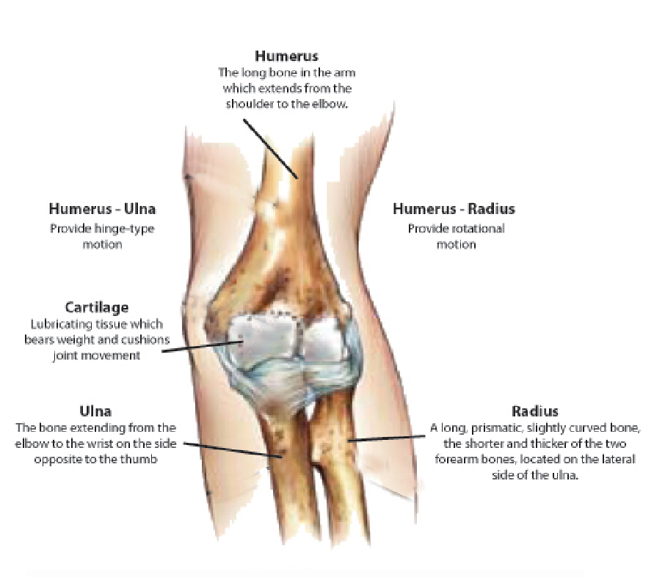
UR Label Medications
9815 2555

 | Dressings
 | The incisions are usually closed with small tapes and additional stitches The wounds are covered with a showerproof plastic dressing and a bandage.
 | Your Dressing Protocols for the next 2 weeks is -
Elbow Surgery
This handout provides information about what to expect and how to care for your elbow after surgery. It is provided as a general guide and does not constitute nor replace specific medical advice.
Surgeries that are structurally stable will be allowed to move post operatively. Your Physiotherapist and Surgeon will discuss this with you. For operations that require protecting, a cast will be applied to your arm  initially. | Sling
OPEN SURGERIES- These are performed through a cut, generally to the side of the elbow. Open surgeries tend to be bigger surgeries and therefore usually require greater protection.  ARTHROSCOPIC SURGERIES- These surgeries are performed through keyholes. They are quite common nowadays and the majority of elbow procedures can now be done this way. Generally following keyhole surgery, you can get the elbow moving sooner. | You will have a sling following your surgery. If you are not in a cast, you can come out of the sling for gentle exercising and showering. Patients in a cast should wear the sling when upright to reduce the stress on the shoulder and neck.

Review
Yo u s h o u l d h a v e a n appointment made 1-2 weeks f o l l o w i n g y o u r s u r g e r y. Physiotherapy may start after this.

Driving
T h i s w i l l v a r y g r e a t l y d e p e n d i n g u p o n y o u r circumstances. Your surgeon will discuss with you time frames for driving.
Activities
Unless otherwise instructed you cannot take weight through your arm. You are not to move or hold the arm by itself. All movements must be passive and supported.

Getting dressed, thread your arm through your sleeve first and off last. Button up shirts or loose t shirts are best.

Time off work depends upon the type of procedure and the job that you do. Most patients return to sedentary work after a couple of weeks. Getting to and from work will be harder than you think and your elbow will be easily irritated. Your Specialist and Physio will be able to guide you with this.

Sleeping
Comfortable sleeping positions can be difficult to find. Generally semi reclined positions work best. Use either lots of pillows or a recliner chair if you have one. So long as the arm is not under pressure, whatever is comfortable is the r ight position.

Medication
You will be provided with m e d i c a t i o n u p o n y o u r departure from hospital. Follow the instructions as described to you by your nurse. As a general rule, your medication requirements should continue to decrease over the early post-operative period.
Remember if you are using codeine based products that constipation can be an issue so keep up the water and a fibre based product such as Metamucil/ Coloxyl can be of assistance.

Physiotherapy
You will be seen by a physiotherapist whilst in hospital at the request of your s u r g e o n ( f o r u n i n s u r e d patients there will be a small fee for this) to ensure your recovery is as quick as possible. Exercises and advice will be given to help get you going and you will be shown how to use your sling. The most important thing in the first couple of weeks is to rest and ice your elbow. This will give it the best opportunity to heal, and reduce the chance of complications. Rehabilitation commences at 1-2 weeks to maintain your allowable movement. You can gently move the elbow by itself
You will require extensive therapy to get the most from your operation. Unlike a lot of o t h e r p r o c e d u r e s , rehabilitation in this instance involves low load repetitive movements. Quality not Quantity is the key here. You must not use heavy weights or resistance with your a r m . Yo u r S u r g e o n o r

Physiotherapist will be able to guide you on time frames regarding this.
Please call the Physiotherapist on 9815 2555 if you have any queries.

Complications

Elbow Surgery is generally a very safe procedure and complications are uncommon, however despite the highest s u r g i c a l s t a n d a r d s a n d precautions they can occur. Potential serious problems include infection and vein thrombosis (blood clots). An onset of fevers or sweats, or increasing redness and discharge from or around the wound can indicate that an infection is present. Please call if this occurs.Likewise, p l e a s e c a l l i f t h e r e i s d i s c o m f o r t c a u s e d b y bandages that are too tight or are loose and have become ineffective.

If you experience fevers, p e r s i s t e n t s w e l l i n g o r bleeding or unusual pain in the arm or calf you should call the ward on 9009 3800 or contact your surgeon or attend to your GP or nearest h o s p i t a l e m e r g e n c y department.

You may also experience numbness in the elbow or arm due to minor nerve damage which is normal with surgery. This can take months to resolve.

All information in this brochure is a guide and is the opinion of Glenferrie Private Hospital

EXERCISES
We generally don't like you to be too active following your elbow surgery. Keep it pretty quiet for the first week and progress to gentle everyday activities over the next few weeks. The most important thing is rest. However you can perform these simple exercises a 3-4 times a day without risk.

Ankle pumps

Move your feet up and down from the ankles for 30 seconds. Repeat hourly when resting.

Hand exercises

Fully open and close your hand. Repeat 10 times.

Rotate your wrist around in circles, and turn your palm up and down. Gently over press the end range. Repeat 10 times each.

Elbow Exercises

Bend and straighten your elbow whilst its supported. Gently over press the end ranges if discussed with the Physio. You can take it out of the sling for this. Repeat 10 times each.

Scapular Exercises

Gently pull your shoulder blades down and together towards your spine. Hold 3 seconds repeat 10 times.

If any of these exercises cause significant pain, please contact your physiotherapist or surgeon.

ICE
Cryotherapy is beneficial in the first few weeks. In the first 72 hours ice your elbow about 6 times a day (every few waking hours) for 20 minutes. Thereafter ice when the arm is sore or irritated as it will assist with pain and inflammation. Gentle heat after the first two weeks can also assist with pain and tension but avoid it earlier as it may promote bleeding.

The advice contained in this handout is appropriate for the first week after your operation, however the average recovery from elbow arthroscopy takes 6 weeks. Further physiotherapy to reduce swelling, regain range of motion and strength, and prepare for return to work or sport, is often required. Glenferrie Sports and Spinal Clinic is located within Glenferrie Private Hospital and The Hawthorn Aquatic and Leisure Centre, specialises in Orthopaedic surgery rehabilitation. We work closely with the surgeons who performed your operation.

It is usually possible to arrange a physiotherapy review to follow immediately after your review with your surgeon. Call our office on 9815 2555 if you would like to book an appointment.

Reviewed 1.9.19

