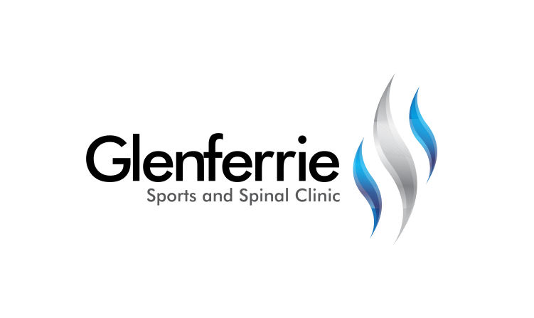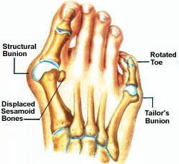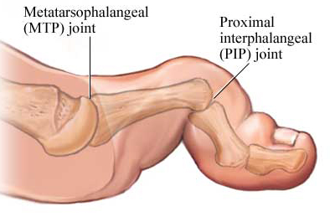

[Editable section]

Your clinic’s details

**[phone]**

[Editable section]

**Your clinic logo**

Physiotherapy

Hand Therapy

Podiatry

Massage

Naturopath

**9815 2555**

# Bunions

Bunions are a common deformity in the community. They are thought to occur due to a muscle imbalance that is often inherited. Inappropriate footwear may exacerbate the condition; however, it is not usually the underlying cause. Bunions worsen with advancing age and can eventually cause pain and deformity. The bunion may also result into damage to other parts of your feet. A bunion may be painful in itself, but what is more common is further pain caused by pressure from shoes over the prominent area. This results in inflammation and increased pain. Pain is felt because of their size and abnormal biomechanics. The time to have treatment is when they cause significant pain or you have difficulty in finding comfortable footwear.

It is not entirely certain what causes a bunion and/or lesser toe deformities to develop. However, they may be inherited or may be acquired due to muscle imbalance. Inappropriate footwear is not usually the cause of the deformity but may be a contributing factor in susceptible individuals.

Tight shoes do, however, cause pain and redness over prominent bony areas. Generalised ligament laxity, abnormal foot mechanics, and tight Achilles tendons may also contribute.

Hammer Toes

Various names (claw toe, hammer toe, mallet toe, curly toe) are used to describe the deformed lesser toes (smaller toes); they often develop as a result of a bunion deformity but can also occur without a bunion. The second toe is the most commonly affected. Painful callosities cause pain, difficulty finding shoes, and difficulty walking. With time, a flexible deformed toe may become a stiff deformed toe.

The joints at the base of the toes (metatarsophalangeal) may become inflamed and may displace, leading to problems with pain under the metatarsal heads in the ball of the foot. This may feel like there is a pebble permanently in your shoe.

# Treatment

The foot is actually composed of more than a single joint. It is better understood as a ‘complex’, composed of a number of different structures.

1. Ankle
2. The Rear Foot
3. The Mid Foot
4. The Fore Foot

Treatment for foot problems first requires the correct diagnoses. Upon assessment, further investigations may be required such as an xray or scan (such as an ultrasound or MRI) to assist with confirmation.

9815 2555

Glenferrie Sports and Spinal

**Physiotherapy**

Matthew Hopkinson

Sarah Forsyth

Kseniya Vasyanska

*Emily Lam*

**Hand Therapy**

Hamish Anderson

**Podiatry**

Ben Holland

Ryan Cornwall

**Massage**

Jacqueline Stavridis

Leigh Baker

**Naturopath and Nutrition**

Anna Boetto

# Conservative Treatment

All bunions are permanent unless surgically corrected. However, there are some measures you can take to be more comfortable or to slow a bunion’s progression. For many people, it may simply be a matter of wearing properly fitting shoes. Be sure to choose low-heeled, comfortable shoes that provide plenty of space for your toes and the widest part of your foot.

Other ways to help can be maintaining a normal weight, protecting the bunion with a moleskin or gel-filled pad which you can buy at a pharmacy, and using shoe inserts to help position the foot correctly. These can be over-the-counter arch supports or prescription orthotic devices. Taking non-steroidal anti-inflammatory drugs such as ibuprofen can help as well.

# Operative Treatment

If your bunion is causing pain, your specialist may recommend surgery. Your doctor may also recommend surgery because bunions can result in other painful foot problems such as hammertoes, bursitis, a bunion below the little toe, or pain in the balls of your feet. Surgery can be done on mild or severe cases.

When patients come in at an older age, it is usually because the bunion is causing other problems; for these patients, the pain is more constant or is creating problems with the second toe.

The goal of surgery is to return the big toe to its correct position. A surgeon puts bones, ligaments, tendons, and nerves back into correct order, removes the bump, and controls and reduces unnatural forces through the joint.

There are many variations on the choice of osteotomy carried out, but modern forefoot surgery usually involves the procedure known as a scarf osteotomy. An incision (cut) is made along the inside of the bunion. The bone cut is made in the first metatarsal and the fragments are displaced into a more normal position. The bone is held in position by two small surgical screws. The screws are buried in the bone so they usually do not need to be removed. The fix is stable and there is usually no need for a plaster cast post-operatively.

The bony protrusion (bump) is trimmed at the same time as the cut is made. The soft tissues attaching to the outside of the big toe are often tight and may be released to allow correction of the toe. This may be done through a small second incision on top of the foot.

A further procedure, known as akin osteotomy, may be carried out on the big toe at the same time. This involves removing a wedge of bone from the big toe; the aim of this is to achieve a better correction of the sideways deviation of the big toe. The bone is fixed in position using a staple or stitch.

Hammer toes are managed with soft tissue procedures, such as tendon release (tenotomy) and tendon transfers, and are usually sufficient for flexible deformity. Fixed deformities are usually treated by operations on the bone around the deformed joint with a wire being placed to maintain position of the toe as it heals. The wire protrudes from the end of the toe and is removed between four to six weeks in clinic (when the two bone ends have begun to join). Removal of the K-wire is relatively painless and does not require an anesthetic.

Recently, there are new techniques involving micro incisions that heal more quickly and will allow faster progression. Your surgeon can discuss this option with you.

*All information in this brochure is a guide and is the opinion of GSSC